

Year 10 Big Bang Physics
2018
The Universe
Response Task

Name: __________________________________

Time Allowed: 40 minutes

 | Mark | %
Total | / 37

Section A: Multiple Choice

1. Why do some people suggest the universe is like inflating a balloon?
a) Because like the universe, over inflated balloons ultimately end in a big bang.
b). The universe is getting bigger due to the stretching of space time.
c). As with the inflation of a balloon the universe is expanding in all directions.
d). The oldest galaxies are on the outer edge of the universe.

2. Star’s produce energy by which of the following processes
a) The constant movement of the gravitational fields which surround the sun.
b) The interaction between the sun’s gravity and hydrogen fission.
c) The interaction sun’s gravitational and electromagnetic fields.
d) The fusion of two atoms to produce larger atoms and energy.

3. Which of the following shows the correct order moving from largest to smallest
- Universe>star>galaxy>moon
- Galaxy>Star>Universe>planet
- Universe>galaxy>planet>moon
- Star>planet>Galaxy>Universe

4. The basic premise of the Big Bang theory is it is a possible explanation for:
a) The formation of Earth
b) The formation of stars
c) The formation of the solar system
d) The formation of the universe

5. The Big Bang is thought to have occurred about
- 13.8 million years ago
- 138000 years ago
- 13.8 billion years ago
- about the time life appeared on earth

6. The Big Bang is thought to have started
- a very hot, small dense single point
- when a supernova exploded
- inside a black hole in the early universe
- ten million years after time started

7. Consider the following dimensions

Mass
Time
Length

Which of the above can be varied according to the special theory of relativity?
- Mass
- Time and mass
- Length and time
- Mass, time and length

8. Which of the following statements is true regarding the speed of light
- the speed of light is dependent on the speed of the source
- mass and time cannot be varied at high speeds
- the speed of light is independent of the source
- the speed of light is always slower then the speed of sound

9 A space ship 200 years from now is loaded up with provisions and sent out into space at 0.95 times the speed of light. It travels away from the Earth for 5 Earth years, stops, and then returns to earth at the same speed.
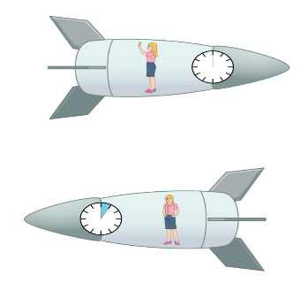
What will the Earth bound observers notice about the ship when it returns?
- The crew are a couple of days younger than equivalent people on Earth
- The crew are many years older than the equivalent Earth people
- The clocks on the ship would have stopped for the whole trip
- The crew are several years younger than their friends on Earth

10. If a space craft is heading out of the solar system at 0.5 times the speed of light and the captain inside this spaceship shines a light in the direction of motion, what will be the speed of the light relative to another space ship floating motionless nearby?
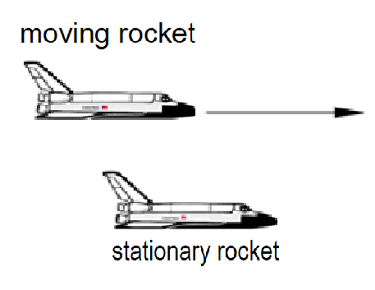
- 1.5 c
- 0.5 c
- c
- 0.75 c

11. A stationary observer watches a very fast space ship zip past at 0.5 times the speed of light.
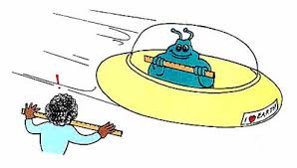
To the observer the
- space ship will appear to be shorter in height
- space ship will appear wider
- space ship will appear thinner in width
- time on their watch will slow down briefly

12. In a thought experiment a train is moving at constant speed of 0.8 c. A lamp is located at the midpoint of a carriage. There are doors W and Z located at each end of the carriage which open automatically when light from the lamp reaches them.

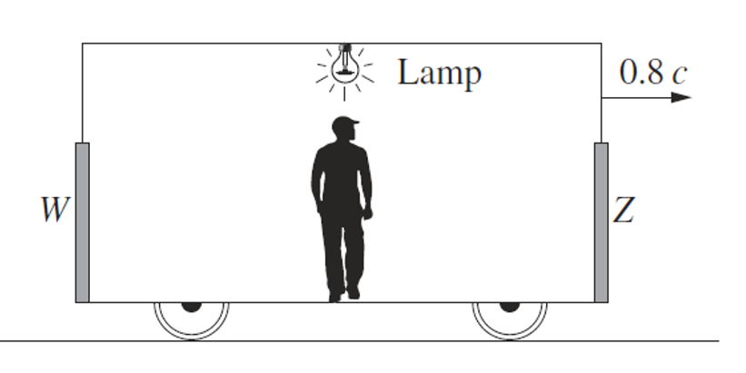

The passenger standing at the midpoint of the carriage switches on the lamp
Which of the statements below best explains what the passenger observes about the doors?

- Z opens before W because the lamp is moving towards Z.
- W opens before Z because W is moving towards the lamp.
- W and Z open simultaneously because the lamp and the doors are all travelling at the same speed.
- W and Z open simultaneously because the distance from the lamp to each door has contracted by the same amount.

Read through the article below and answer the questions
WHAT IS THE UNIVERSE?
History
In ancient times, listing the ingredients of the universe was simple: earth, air, fire and water. Today, scientists know that naming all of that, plus everything else familiar in everyday life, leaves out 95 percent of the cosmos's contents'.
From the atoms that make up an astronomer, to the glass and steel of a telescope, to the hot plasma of the stars above -- all ordinary stuff accounts for less than 5 percent of the mass and energy in the universe. "All the visible world that we see around us is just the tip of the iceberg," says Joshua Frieman, an astrophysicist at the University of Chicago and the Fermi National Accelerator Laboratory in Batavia, Ill.
The rest is, quite literally, dark. Nearly one-quarter of the universe's composition is as-yet-unidentified material called dark matter. The remaining 70 percent or so is a mysterious entity known as dark energy that pervades all of space, pushing it apart at an ever-faster rate.
Stars
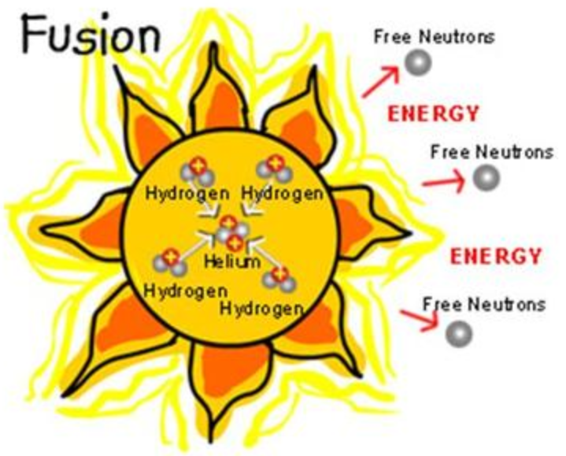
Basically, stars are big exploding balls of gas, mostly hydrogen and helium. Our nearest star, the Sun, is so hot that the huge amount of hydrogen is undergoing a constant star-wide nuclear reaction, like in a hydrogen bomb. Even though it is constantly exploding in a nuclear reaction, the Sun and other stars are so large and have so much matter in them that it will take billions of years for the explosion to use all the "fuel" in the star. The huge reactions taking place in stars are constantly releasing energy (called electromagnetic radiation) into the universe, which is why we can see them and find them on radio telescopes such as the ones in the Deep Space Network (DSN). Stars, including the Sun, also send out a solar wind and burst out occasional solar flares.
Planets
Throughout history, the definition of what a planet is has changed and meant various things at the same time depending on who was defining it. Objects like the Sun, which we would now scoff at defining as a planet, was once considered a planet as was the Moon. The planets that go around our sun have enough mass to generate a gravitational field capable of holding a moon in satellite motion. Most of the planets in our solar system probably formed only around 4.5 billion years ago, and new planets are still forming today around other stars.
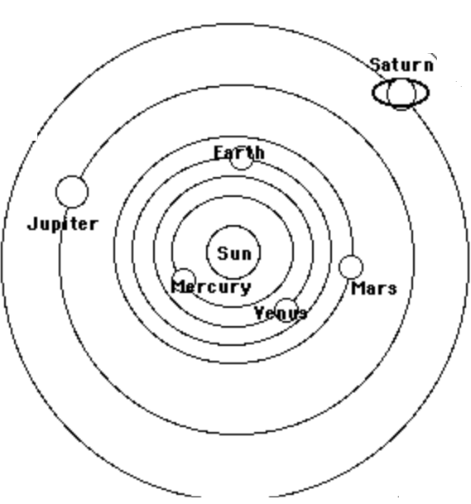

Officially there are three requirements which need to be satisfied to qualify as a planet. Firstly, it has to orbit around the sun. Secondly, it must be big enough to have enough gravity to force it into a spherical shape. And thirdly, it must be big enough that its gravity cleared away any other objects of a similar size near its orbit around the Sun.
Planets that form closer to a star are hotter, of course, but also usually smaller and harder, made mostly of iron. Planets that formed farther away from their star are colder, larger, and softer, made mostly of gases. There are planets around many other stars besides the Sun, and like our planets some of them have water on them, and organic molecules like methane, but we don't know yet whether there is anything alive on them.

Galaxies
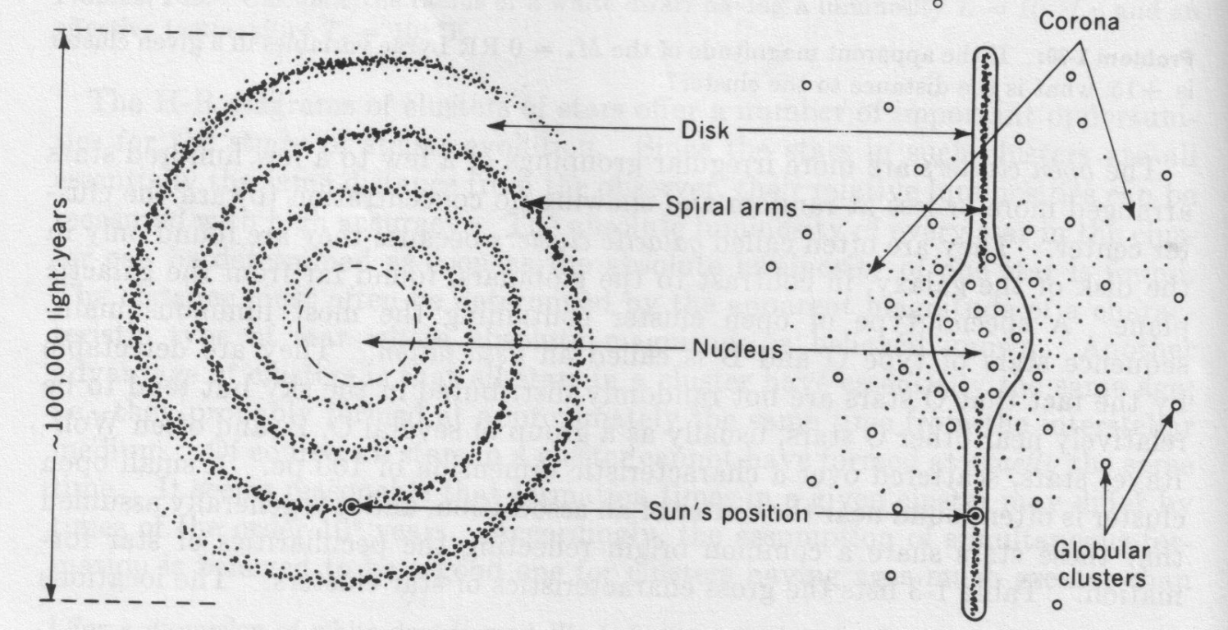
Galaxies are large systems of stars and interstellar matter, typically containing several million to some trillion stars, of masses between several million and several trillion times that of our Sun, and can range in length from a few thousand light years to 100,000s light years in length. Typically galaxies separated by millions of light years. They come in a variety of flavors: Spiral, lenticular, elliptical and irregular. Besides simple stars, they typically contain various types of star clusters and nebulae.
We live in a giant spiral galaxy, the Milky Way Galaxy, of 100,000 light years diameter and a mass of roughly a trillion solar masses; our Sun is one of several 100 billions of stars of the Milky Way. The nearest dwarf galaxies, satellites of the Milky Way, are only a few 100,000 light years distant (and closer in case of some dwarfs which are currently merged with the Milky Way), while the nearest giant neighbor, the Andromeda Galaxy, also a spiral, is about 2-3 million light years distant.

A different matter
Dark matter made its debut in 1933, when Swiss astronomer Fritz Zwicky measured the velocities of galaxies in a group known as the Coma cluster and found them moving at different rates than expected. Some unseen and large amount of "dunkle Materie," he proposed in German, must exist, exerting its gravitational effects on the galaxies within the cluster.
Astronomer Vera Rubin confirmed dark matter's existence in the 1970s, after she and colleagues had measured the speeds of stars rotating around the centres of dozens of galaxies. She found that, counter intuitively, stars on the galaxies' outer fringes moved just as rapidly as those closer in - as if Pluto orbited the sun as quickly as Mercury. Rubin's work demonstrated that each galaxy must be embedded in some much larger gravitational scaffold.
The leading candidate for a dark matter particle is the vaguely named "weakly interacting massive particle," or WIMP. Such particles would be "weakly interacting" because they rarely affect ordinary matter, and "massive" because they must exceed the mass of most known particles, possibly weighing in at as much as 1,000 times the mass of the proton. But nobody has yet definitively detected a WIMP, despite decades of experiments designed to spot one.
Mysterious forces
Spotting dark matter may prove to be easier than understanding dark energy, whose mysteries make scientists feel like mental wimps.
Albert Einstein unknowingly ushered dark energy onto the stage in 1917, while modifying his new equations of general relativity. Einstein wondered why gravity didn't make the universe contract in on itself, like a balloon with the air sucked out of it. In 1929, though, Edwin Hubble solved Einstein's problem by reporting that distant galaxies were flying away from each other. The universe, Hubble showed, was expanding. It had been zooming outward ever since the Big Bang gave birth to it. Something funny was going on, giving the cosmos a repulsive push. So in 1998 Michael Turner, a cosmologist at the University of Chicago, dubbed the thing "funny energy" at first, before settling on "dark energy."

Use the article and your knowledge of the universe to answer the following questions.

- According to the article, all matter that we can observe makes up only 5% of the content of the Universe. What constitutes the other 95%?
(2 marks)

- What is the name of the radiation produced by the sun during it’s nuclear process? (1 mark)

- Why does earth and all the other planets circulate around the sun?
(3 marks)

- Why do the planets closer to the sun seem to take less time to circulate around the sun compared to those planets further away.
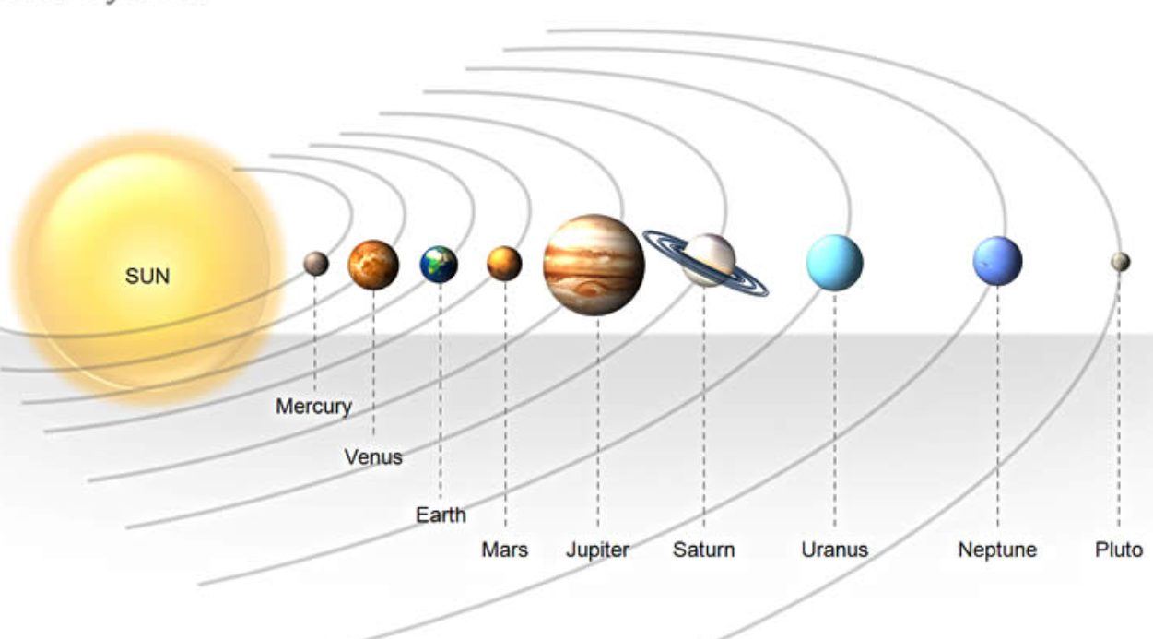
(2 marks)

- Early astronomers mistakenly classified both the moon and the Sun as a planet. Give reasons as to why we no longer classify them as planets
(2 marks)

- If you directed a powerful laser in to night sky above you, roughly how long would it take the beam to reach the other side of our galaxy if it travelled through the center.
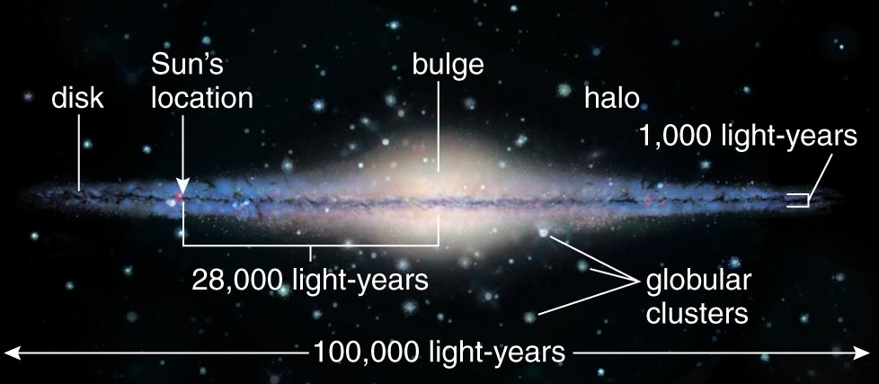
(2 marks)

- How did Vera Rubin confirm the existence of dark matter in 1970? (2 marks)

- Astronomers have theorized the existence of WIMPS (weakly interacting massive particles). Why do astronomers believe the particles must be massive? (2 marks)

- What was Einstein’s problem with gravity and the universe?
(1 marks)

- What was Hubble’s solution to Einstein’s problem with gravity and the universe.
(1 marks)

- Why do think “dark matter” was originally called “funny matter” by early cosmologists.
(2 marks)

- Describe the currently most accepted model used to explain the emergence of the universe.
(2 marks)

- List the significant evidence which led to the acceptance of this model for the beginning of the universe.
(3 marks)

